Design-1: (difficulty: standard)
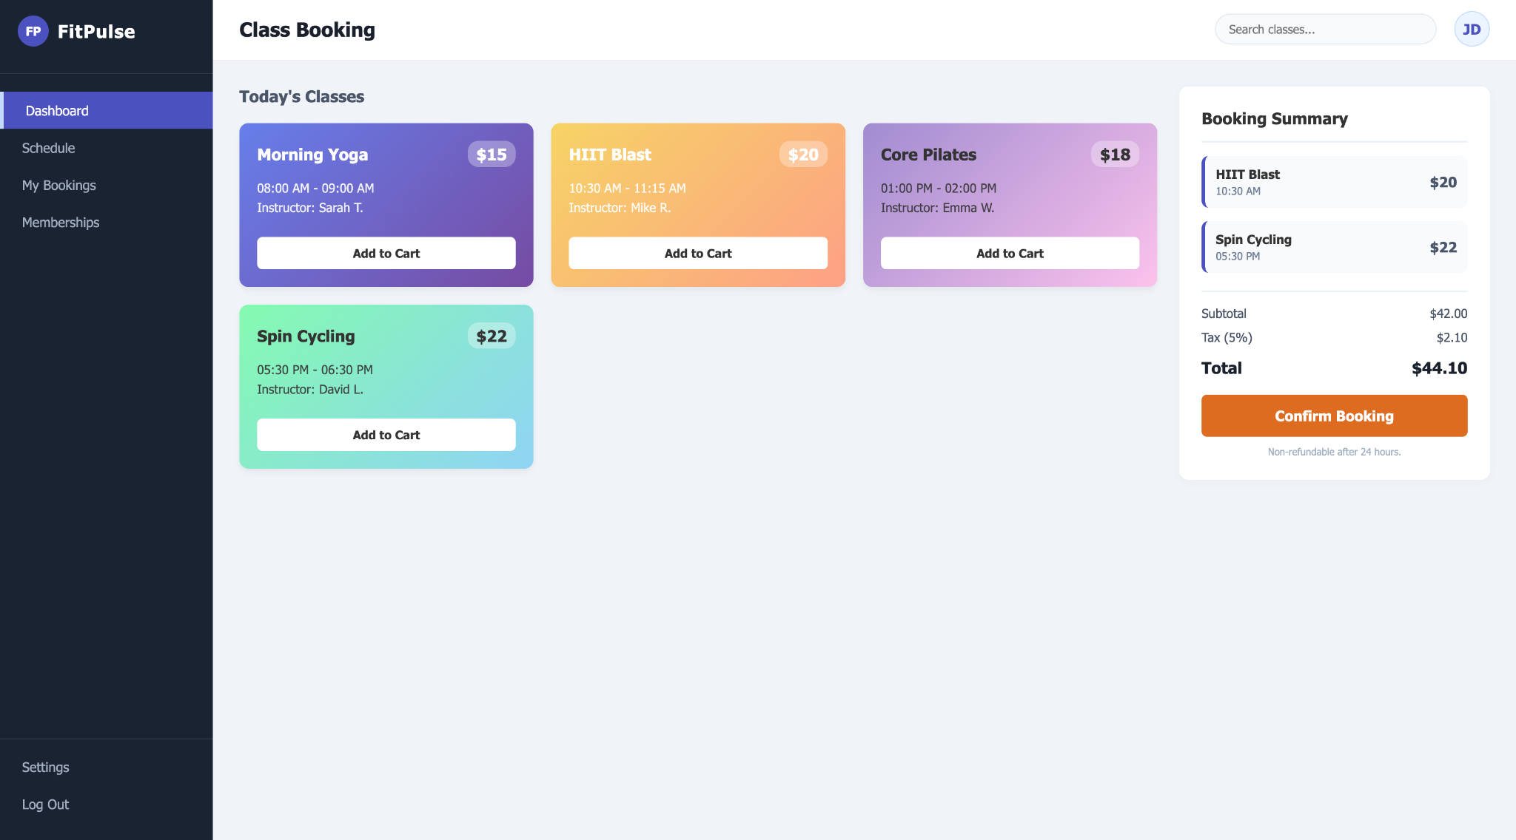

Design-2: (difficulty: very easy)
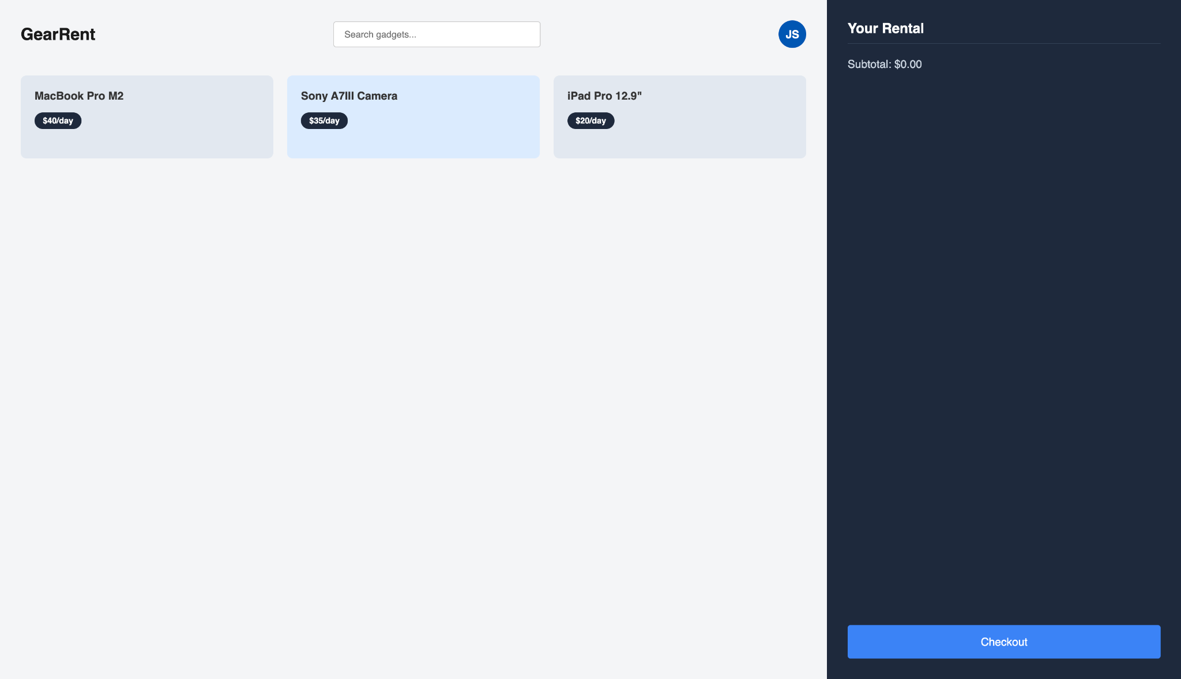

Design-3: (difficulty: very easy)
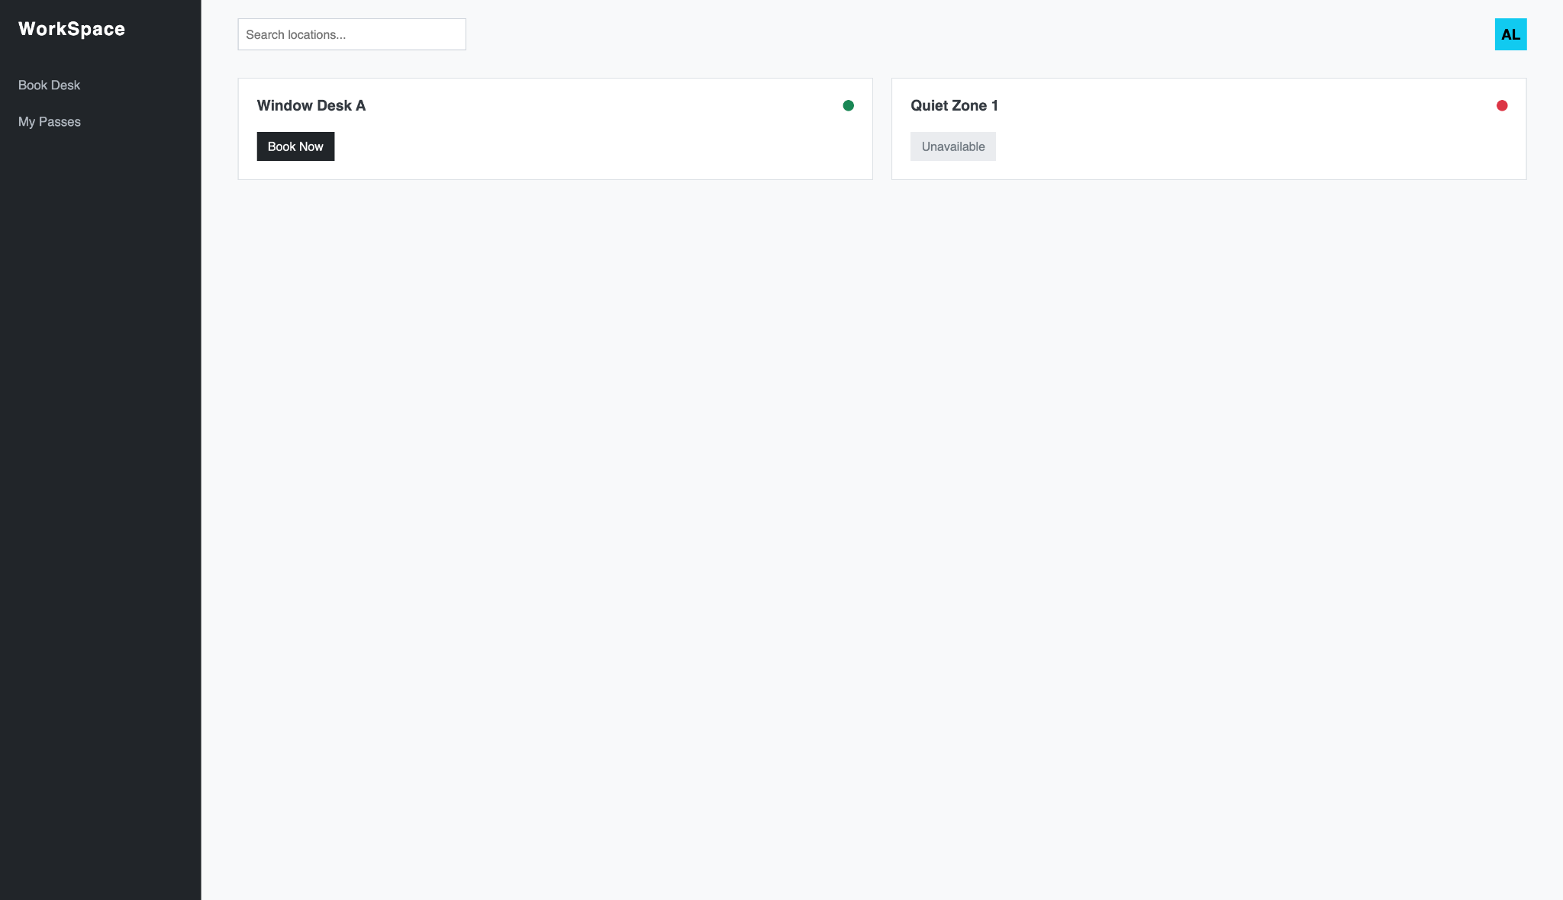

Design-4: (difficulty: easy)
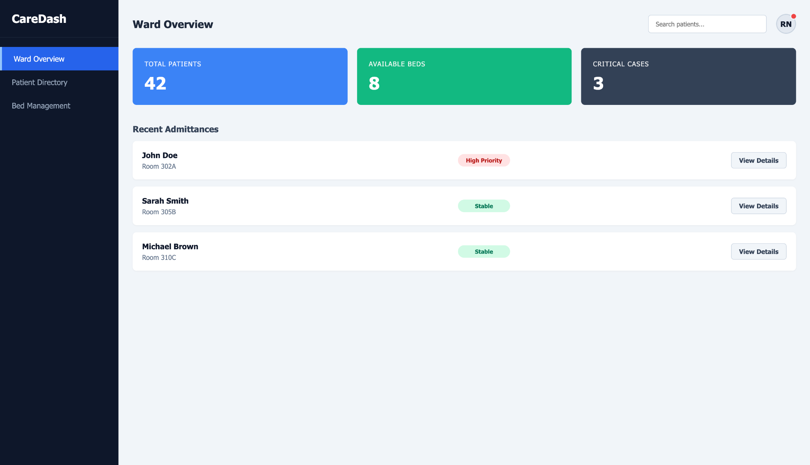

Design-5: (difficulty: easy)
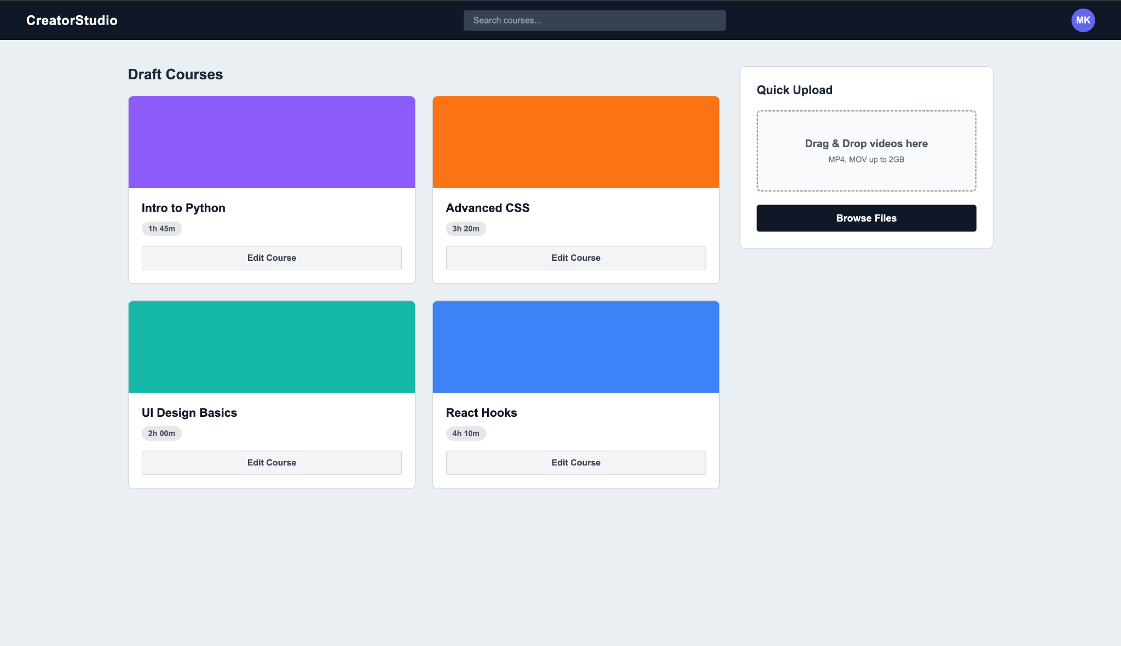

Design-6: (difficulty: standard)
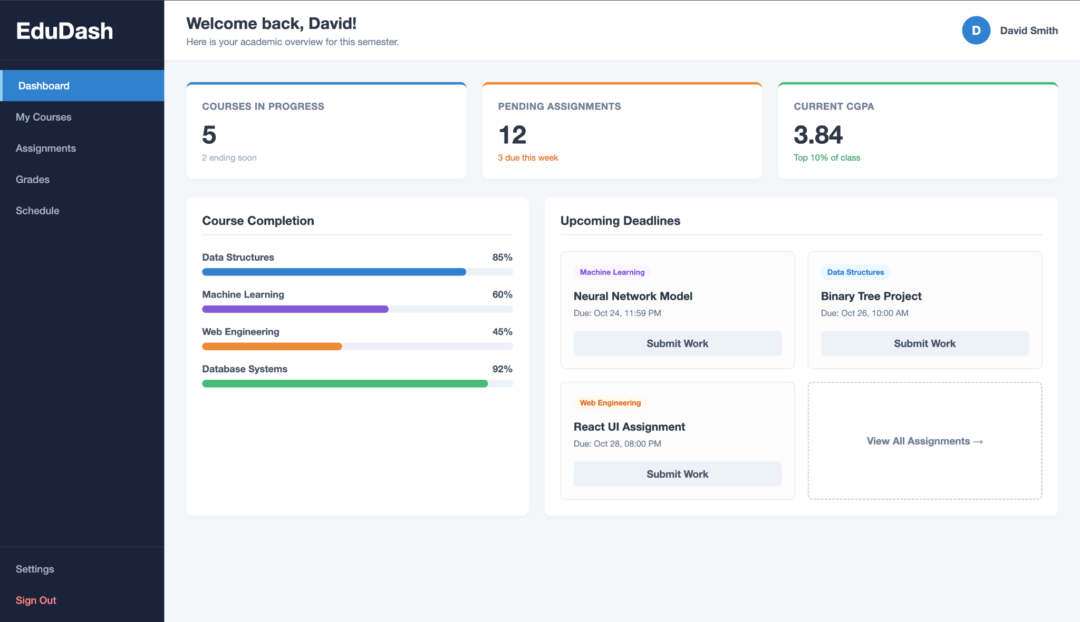

Design-7: (difficulty: standard)
